Why did Jesus teach us the Lord’s prayer as a way to pray?



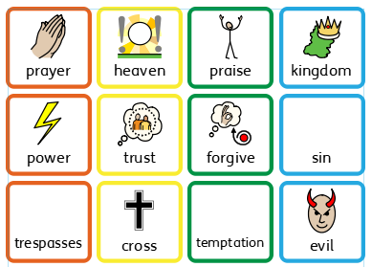

|  |  |
| --- | --- |
| AT1 Target  I can explain why the Lord’s prayer is important to Christians | AT2 Target  I can talk about who looks after me |