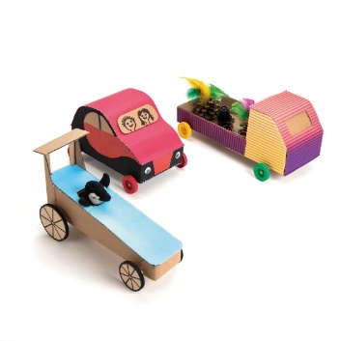Vehicles

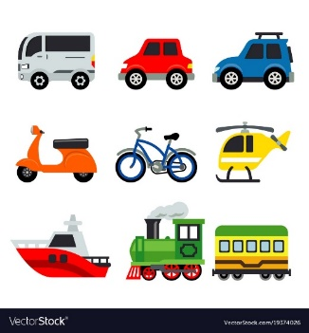

|  |  |
| --- | --- |
| **Key Disciplines** | **Mechanisms** |
| **Aims** | Children to create a moving vehicles using their understanding of chassis, axels and wheels. |
| **Outcomes** | To develop knowledge of how things move. |

**Key Vocabulary**

Chassis

Wheel

Axel

Spin

Shape

Design

Produce

Evaluate

**Processes**

* I can design useful pleasing products for myself and other users based on a design brief
* I can generate, develop, model and communicate my ideas through talking, drawing, templates, mock-ups and IT
* I can choose tools I would like to use and select materials based on my knowledge of their properties
* I can safely measure, make out, cut and shape materials and components using a range of tools
* I can investigate different techniques for stiffening a variety of materials and explore different methods of enabling structures to remain stable
* I can explore and use mechanisms such a lever, sliders, wheels and axles in products

**Evaluate**

* I can decide how existing products do/do not achieve their purpose.
* I can talk about their design as they develop it and identify good and bad points.
* I can say what I like and do not like about items I have made and attempt to say why.
* I can evaluate and assess existing products and those that I have made using a design criteria